# **ELECTRIC VEHICLE POWERTRAIN MODELLING, SIMULATION AND VALIDATION**

|  |  |  |
| --- | --- | --- |
| **Mohd Aadil**  *Electrical Engineering, DTU, Delhi* mohdaadil_ee21b8_37@dtu.ac.in | **Md. Adeen Ashraf**  *Electrical Engineering, DTU, Delhi* md.adeenashraf_ee21b8_34@dtu.ac.in | **Md Rehaan**  *Electrical Engineering, DTU, Delhi* mdrehaan_ee21b8_33@dtu.ac.in |
| **Brijendra Sangar** *Electrical Engineering, DTU, Delhi*  brijendra_2k21phdee30@gmail.com |  | **Mini Sreejeth**  *Electrical Engineering, DTU, Delhi* minisreejeth@dce.ac.in |

***Abstract—A Permanent Magnet Synchronous Motor (PMSM) can be considered for the vital duty of transporting energy from the battery pack to the wheel system of an electric vehicle (EV) in an electric powertrain (PT) due to its high torque and power density. An EVPT test bench, which simulates the EV propulsion system, is presented in this work. We examine the EVPT model under different operational situations. The traction motor in the EVPT system is a PMSM. The energy source is a lead acid battery, which uses a voltage source inverter (VSI) to deliver electrical energy to the PMSM. Both the experimental and simulation results are given and validated. This work is helpful in expanding the control of the PT system and aids in understanding the real-time operating environment of EVs.***

***Keywords: Drive Cycle, PMSM, Electric Vehicle, Modelling, MATLAB, Powertrain.***

# INTRODUCTION

The electric vehicle (EV) business has grown rapidly on a global scale during the past few decades. India, one of the biggest automakers in the world, makes a range of EV models. The Indian government has launched and allocated funds for several national electric mobility initiatives aimed at addressing various challenges such as vehicle pollution, advancing the skills of automakers, and guaranteeing the country's energy sustainability [1] [2]. Using electric vehicles (EVs) reduces the use of fossil fuel-based economies, greenhouse gas emissions, and pollution caused by cars. An internal combustion engine (ICE) is not used in an electric vehicle's propulsion system; instead, electric vehicles and controllers are utilized. The EV emulation system, designed to examine the EVPT system in a real-time setting, is presented in this work. To investigate PMSM's potential in powertrain engineering, it was used as a traction device [3].

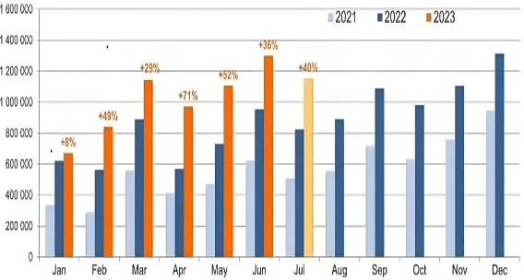Emerging technology and changing consumer needs are expected to generate major breakthroughs in the powertrain of electric vehicles (EVs) in the future [4]. The adoption of solid-state batteries, which offer improved safety, quicker charging periods, and a better energy density than conventional liquid or gel electrolyte-based batteries, is one of the major advancements. Advanced motor technologies, such as high-efficiency axial flux motors and integrated motor drives, are expected to increase power density and efficiency while reducing system complexity.

Fig. 1. Global EV Sales

Fig.1 displays global EV sales during the previous three years. It provides an explanation of recent statistics on EV sales worldwide, and patterns indicate that more electric mobility will be available in the upcoming years [5].

Power electronics advancements, in particular, the application of silicon carbide (SiC) and gallium nitride (GaN) devices, will lead to more efficient inverters and converters. Additionally, EVs will be able to provide backup power and contribute to the stability of the energy grid thanks to vehicle-to-everything (V2X) communication, which includes capabilities for vehicle-to-home (V2H) and vehicle-to-grid (V2G). The integration of autonomous driving technologies and enhanced connectivity will further optimize powertrain performance [6]. Finally, the use of lightweight materials and improved thermal management systems will enhance overall vehicle efficiency, driving the evolution of EV powertrains toward greater sustainability and performance. The modelling and simulation of an electric vehicle's powertrain are presented in this work. The EVPT system is designed and analysed in a variety of operational scenarios, such as braking and acceleration. Also, the developed model is tested and validated using a standard drive cycle, IM240, and found to be robust enough to cater for the real driving pattern.

This paper itself is divided into five separate sections, starting with the introduction. Section II describes the EVPT system in detail wherein the vehicle, transmission, PMSM drive, and battery models are explained. In Section III, a simulation of the IM240 drive cycle used to validate the model is provided. Results are shown in Section IV, while Section V has a discussion and conclusions.

# EVPT SYSTEM

To effectively comprehend the vehicle dynamics, EV propulsion system modelling is essential. A MATLAB/Simulink EVPT model is designed and simulated for dynamic conditions. It is compatible with various traction motor operating modes. Unlike conventional PT systems, a three-phase inverter system uses the battery to provide electrical energy to the traction motor. Through the transmission unit, the mechanical energy generated at the electric motor shaft is delivered to the wheel system of the electric automobile. Fig. 2 shows the Simulink model of the EVPT system.

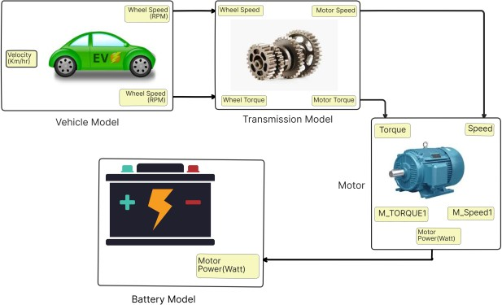An e-rickshaw is used in the vehicle model and the motor parameters are given in Table 1. The EVPT system's gear system and transmission unit are the pulley system and extended motor shaft, respectively, while the PMSM is a traction device. 31Ah lead acid battery is used as the energy source.

Fig. 2. Simulink Model

## *Electric Vehicle Modelling*

Motion's effects on the system as a whole are reflected in the dynamics of the vehicle. As previously explained, the energy that was turned into the vehicle wheel is then changed again into energy for displacement. The dynamics of tires reflect an application of force to the earth. Consequently, the temporal integral of the power may be used to determine the total energy used at the tire as follows:

$E_{wheel}=\int_{0}^{t}{P_{wheel}\left(t\right)dt}$ (1)

Traction force and vehicle speed, in addition to the following, define road grade, acceleration, and displacement for the electric powertrain that provides instantaneous tractive power to the wheels, or *Pwheel*:

(2)

where *Ft* is the traction force transferred from the motor to the wheels and v is the vehicle speed.

Therefore, if *Fwheel* is negative during regenerative braking, the *Pwheel* will likewise be negative, resulting in a decrease in the total amount of energy utilized.

As depicted in Fig. 3, the vehicle experiences resistive forces that attempt to slow it down as it moves.

Among the resistive forces are:

* **Rolling Resistance**
* **Aerodynamic Drag**
* **Grade Resistance**
* **Acceleration Resistance**

The following equation represents the equation of movement along the longitudinal axis of the electric vehicle:

*Ft = Fhc + Fac + Frr + Fad*  (3)

where *Ft*, *Frr*, *Fad*, *Fhc*, and *Fac* stand for the following: total tractive force, rolling resistance of the road, resistance to aerodynamic forces, resistance to grading, resistance to acceleration, and so on. The details are given in the following section.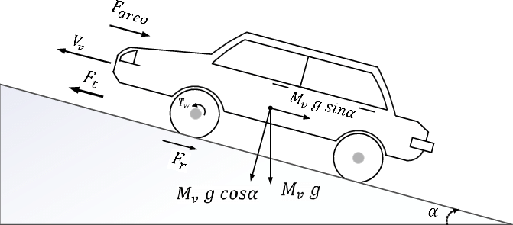

Figure 3.Forces acting during vehicle movement

## *Rolling Resistance*

The resistance to rolling *Frr* is created during rolling by the vehicle tire's friction against the road's contact surface. The tire's material may experience hysteresis as a result of the repeated deflection. Estimating rolling resistance by analytical modeling is highly challenging since it also depends on the type, speed, and features of the road surface of the vehicle.

Therefore, the standard method for expressing the rolling resistance force *Frr* acting on a vehicle in the longitudinal direction is to multiply the dimensionless rolling resistance coefficient by the vehicle's effective normal load. One way to express rolling resistance is as:

*Frr = Crr Mv .g.*𝒄𝒐𝒔(𝑎) (4)

Where *g* is the acceleration constant (m/s2), *Mv* is the vehicle mass (kg), *Crr* is the tire rolling resistance, and *𝑎* is the road angle (radians), which is usually taken as zero for urban driving.

## *Aerodynamics Drag Resistance*

An essential factor in evaluating the effectiveness and performance of EVs is aerodynamic drag resistance, *Fad*. It describes the force that opposes a vehicle's velocity in the atmosphere as a result of the vehicle's surface interacting with the surrounding molecules of air. This resistance is made up of several factors, including lift-induced drag, form drag, skin friction, and interference drag.

Several factors affect aerodynamic drag, including vehicle shape and design, frontal area, surface smoothness, and vehicle speed. Sleek, aerodynamic designs with smooth curves and minimal protrusions help reduce drag. This drag resistance can be written as:

*Fad = 0.5* 𝝆*a Cad Af (Vv + Vwind)****2*** (5)

Where *𝝆a*is air density (kg/m3), *Cad*is aerodynamics drag coefficient, *Af*  is vehicle frontal area (m2), *Vv* is vehicle speed (m/s), and *Vw*is headwind velocity (m/s).

## *Grading Resistance*

Resistance grading *Fhc*, often referred to as grade resistance or hill climbing resistance, is a critical component that impacts how well electric cars (EVs) function, particularly while driving up hills. This type of resistance occurs when a vehicle travels uphill, necessitating additional energy to counteract the gravitational force pulling it downward. The steeper the incline, the greater the grading resistance, as it is directly proportional to the sine of the road grade angle [7].

For electric vehicles, this means that more power from the battery is required to maintain a constant speed while ascending a slope. The increased energy demand can significantly impact the vehicle’s range and battery life, as climbing hills consumes more energy compared to driving on level ground. Factors such as vehicle weight, tire friction, and drivetrain efficiency also influence grading resistance. It can be written as:

*Fhc = Mv.g.*𝒔𝒊𝒏(𝑎) (6)

Where *Mv*is vehicle mass (kg), *g*is acceleration constant (m/s2), and *𝑎* (radians) is the angle between the level road and the horizontal plane.

## *Acceleration Resistance*

Acceleration resistance, *Fac* in electric vehicles is a critical factor that impacts their performance and energy efficiency. This form of resistance arises from the inertia of the vehicle mass that must be overcome to change its velocity. When an EV accelerates, it requires a significant amount of energy to increase the speed of its mass.

This energy demand is particularly pronounced during rapid acceleration or when moving from a standstill. This resistance has a direct relationship to the vehicle's mass and acceleration rate, as stated in Newton's second equation of motion. Consequently, heavier vehicles and those that aim for high-performance acceleration resistance. Acceleration resistance can be stated as:

Fac = Mv a (7)

where *Mv*is vehicle mass (kg), and *a*is vehicle acceleration (m/s2).

## *Transmission Model*

The transmission model is a mathematical representation of how an electric vehicle's (EV) mechanical power is transmitted to its wheels. In this model, wheel speed and torque are converted to motor speed and torque while accounting for the battery's mechanical energy characteristics.

**Key Components of the Transmission Model:**

* **Electric Motor**: The primary source of torque and rotational speed. To power the wheels of an electric vehicle, the motor transforms electrical energy from the battery into mechanical energy.
* **Gear Ratio (G)**: The ratio between the motor's and the wheels' rotational speeds. This is a crucial factor in determining the torque and speed relationship between the motor and the wheels.
* **Wheel Speed (ωw)**: The rotational speed of the wheels, often expressed in radians per second (rad/s) or revolutions per minute (rpm).
* **Motor Speed (ωm)**: The motor's rotating speed is connected to the wheel speed by means of the gear ratio.
* **Wheel Torque (Tw)**: The torque exerted by the wheels, which is the force that drives the vehicle forward.
* **Motor Torque (Tm)**: The torque that the electric motor produces, which the transmission system transfers to the wheels.

**Conversion Equations:**

1. Wheel Speed to Motor Speed:

$ω_{m}=ω_{w}⋅G$ (8)

Here, *ωw* is the wheel speed, *ωm* is the motor speed, and *G* is the gear ratio. This equation shows that the motor speed is directly proportional to the gear ratio for a given wheel speed.

1. Wheel Torque to Motor Torque:

$T_{m}=\frac{T_{w}}{G}$ (9)

The gear ratio, *G*, the motor torque, *Tm*, and the wheel torque, *Tw*, respectively, are represented in this equation. This suggests that the relationship between the wheel torque and the gear ratio and the motor torque is inverse.

## *PMSM Modelling*

Permanent Magnet Synchronous Motors (PMSMs) are pivotal components within electric vehicle (EV) powertrains, renowned for their efficiency, compact design, and precise control capabilities. These motors leverage permanent magnets on the rotor, eliminating the need for separate field excitation, which enhances efficiency by reducing losses and improving density. This efficiency is crucial for maximizing the range of electric vehicles, as PMSMs typically achieve efficiency ratings above 90%. Their ability to produce strong torque at low speeds, which is ideal for the stop-and-go nature of urban driving, also enhances overall vehicle performance [8].

In EV applications, PMSMs play a dual role: powering the vehicle during acceleration and maintaining efficiency during deceleration through regenerative braking. When the vehicle stops, the engine acts as a generator, converting kinetic energy back into electrical energy that is stored in the battery and extending the car's range. This regenerative capability not only improves energy efficiency but also reduces wear on traditional friction brakes, enhancing vehicle reliability and reducing maintenance costs. Table 2 represents the specifications of various components of the EVPT system.

**Table 2**: Specifications of various components of the EVPT system.

|  |  |  |  |
| --- | --- | --- | --- |
| Power (kW) | 3.77 | Moment Of Inertia  (kg-m2) | 1.1 x 10-3 |
| Voltage (V) | 300 | Magnetic Flux  (V-sec) | 0.26603 |
| Torque (Nm) | 12 | Line Resistance (ohm) | 1.93 |
| Poles | 6 | Line Inductance (mH) | 11.4 |

For a PMSM, the voltage equations in the d-q (direct and quadrature) reference frame are:

**d-axis Voltage Equation:**

$v_{d}=R_{S}i_{d}+L_{d}\left(\frac{ⅆi_{d}}{ⅆt}\right)-ω⋅L_{q}⋅i_{q}-λ_{f}$ (10)

Where: *vd* = d-axis voltage, *Rs* = Stator Resistance, *id* = d-axis current, *iq* = q-axis current, *Ld* = d-axis inductance, $ω$ = angular speed of the rotor, *Lq* = q-axis inductance, $λ_{f}$ = Permanent magnet flux linkage.

**q-axis Voltage Equation:**

$v_{q}=R_{s}⋅i_{s}+L_{q}\left(\frac{{di}_{q}}{ⅆt}\right)$ (11)

Where: *vq* = q-axis voltage, *Rs* = Stator Resistance, *is* = stator current [9].

**Electromagnetic Torque:**

$T_{e}=\frac{3}{2}⋅\frac{P}{2}⋅λ_{f}i_{d}+\left(L_{d}-L_{q}\right)i_{d}i_{q}$ (12)

Where: *P* = number of magnetic poles

## *Battery Modelling*

Modelling the battery system in an electric vehicle (EV) involves understanding how the battery interacts with the motor and other components. Here is an overview of the key elements in a battery model for an EV, including how motor power translates into battery power, battery current, battery current rate, and state of charge (SoC) [10].

The Shepherd Battery Model equation is as follows:

$v_{battery}= v_{0}-K\left(\frac{Q}{Q-it}\right)i-R_{0}i+Ae^{-\left(Bit\right)}$ (13)

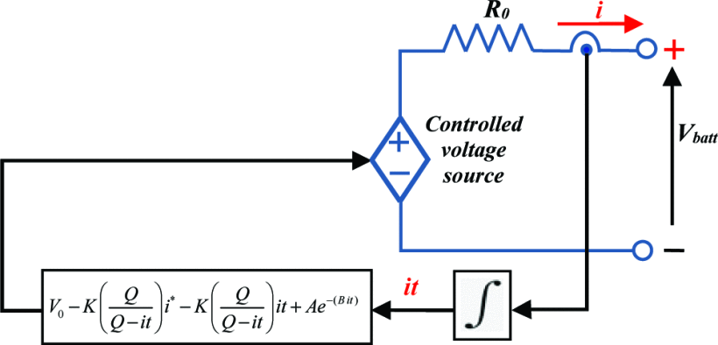

Fig. 4. Equivalent Circuit of Battery Model

## *Battery Power and Current:*

Taking into account other losses and the effectiveness of the power electronics, the battery provides the power, *Pmotor*, that is applied to the motor. To convert motor power to battery power, the following relation is used:

$$P_{battery}=\frac{P_{motor}}{η_{inverter}} (14)$$

Where: *Pbattery*= power drawn from the battery, *Pmotor*= power delivered to the motor, $η_{inverter}$ = efficiency of the inverter.

$$I_{battery}=\frac{P_{battery}}{V_{battery}} (15)$$

where: *Vbattery*= battery voltage

## *Battery Current Rate:*

The battery current rate (or change in current) is important for modelling the dynamic response of the battery. This can be expressed as:

$$\frac{ⅆI_{battery}}{ⅆt}=\frac{1}{V_{battery}}\left(\frac{ⅆP_{battery}}{ⅆt}-I_{battery}\frac{dV_{battery}}{ⅆt}\right)(16)$$

Where, $\frac{ⅆP_{battery}}{ⅆt}$ = rate of change of battery power

$\frac{dV_{battery}}{ⅆt}$ = rate of change of battery voltage

## *State of Charge (SOC):*

The battery's State of Charge (SoC) indicates how much of its full capacity is still available for use. It can be calculated by integrating the battery current over time, considering the battery capacity *Cbattery*.

Where: $SoC\left(0\right)$ = initial state of charge, *Cbattery*= Battery capacity (in Ah), *Ibattery*= Battery current, *t* = time.

## *Battery Efficiency:*

Battery efficiency is crucial for accurate modelling:

$$η_{battery}=\frac{E_{out}}{E_{in}} (18)$$

Where: *Eout* = Energy supplied to the motor, *Ein* = Energy drawn from the battery.

Battery efficiency typically decreases with higher currents and deeper discharge cycles.

# EVPT DRIVE CYCLE

The Simulink model uses a 5.1 kVA, 300V, 3𝜑 permanent magnet synchronous motor. The IM240 drive cycle refers to specific driving conditions and procedures used for vehicle emissions testing.

The term ‘**IM240’** stands for an inspection and maintenance test that takes 240 seconds (4 minutes) to complete [11]. It includes phases such as idling, steady cruising at various speeds including highway speeds, and periods of acceleration and deceleration. By subjecting vehicles to these controlled conditions, the IM240 drive cycle aims to assess the effectiveness of emissions control systems in reducing pollutants emitted into the atmosphere [12]. This testing is crucial for ensuring compliance with environmental regulations and confirming that vehicles meet specified emission standards before they can be certified for road use. Due to the lack of tailpipe emissions in EVs, they do not undergo emission testing, but the drive cycle is applied to EVs to evaluate factors like energy efficiency, range, and overall performance under standardized conditions [13]. The IM240 drive cycle is shown in Fig. 5.

Table 1. Parameters fed into the Simulink model

|  |  |
| --- | --- |
| **Parameters** | **Values** |
| Radius of wheel (m) | 0.2736 |
| Gross vehicle mass (kg) | 225 |
| Gross vehicle weight (kg-m/s2) | 2205 |
| Coefficient of rolling resistance | 0.012 |
| Slope angle (radian) | 0 |
| Frontal area (m2) | 1.73 |
| Coefficient of drag | 0.4 |
| Gear ratio | 6 |
| Efficiency of transmission | 0.95 |
| Efficiency of motor | 0.93 |
| Motor control efficiency | 0.95 |
| Battery voltage (V) | 300 |
| Cell voltage (V) | 3.6 |
| Cell capacity (Ah) | 31 |
| Air density (kg/m3) | 1.225 |

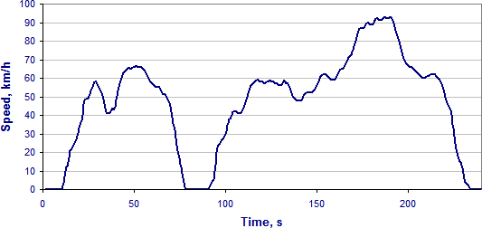

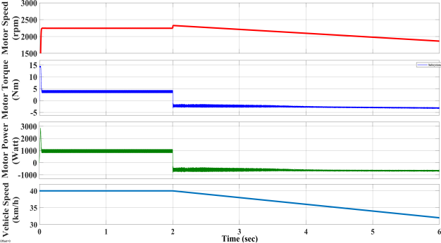Fig. 5. Inspection and Maintenance Drive Cycle

# RESULTS AND ANALYSIS

The EVPT system is simulated using an e-rickshaw as the vehicle model, a PMSM as the traction motor, and a lead acid battery as the energy supply. The outcomes of the simulation are analyzed in this section.

## *Dynamic Analysis*

A MATLAB/Simulink model of the EVPT system is developed and analyzed under different operations of vehicles. The designed model consists of a vehicle body connected via transmission and differential system which is used for transferring mechanical energy in the powertrain system. The performance of the implemented model is tested by running the Simulink model for different cases; Acceleration and braking.

Fig. 7. Braking Mode

## *Acceleration Mode*

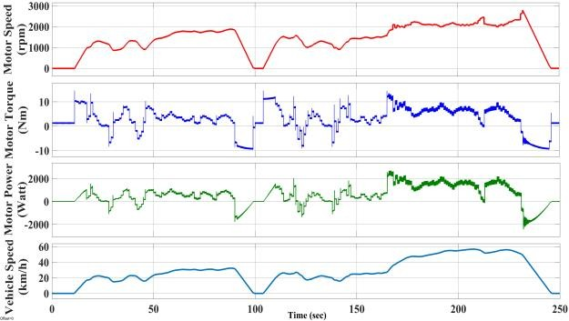It is noticed that the vehicle accelerates with a value of 2 m/s2, and it continues at that speed until there is any interruption in the load, when the model performance is evaluated with an increasing speed with the initial speed of 20 km/hr input at t = 2 sec.

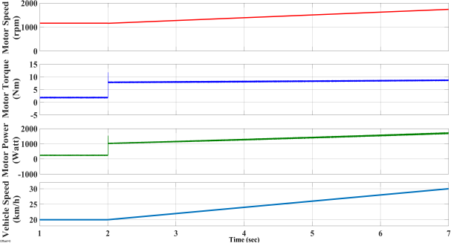The motor achieves the necessary speed with an acceleration of 12.56 rad/s2 when its speed is increased from 1150 rpm to 1750 rpm, generating the requisite q-axis current (Fig. 6).

Fig. 8. Drivetrain Characteristics

Fig. 6. Acceleration mode

## *Braking mode*

To test the motor's braking reaction, a signal to halt is delivered at t=2 seconds. Fig. 7 displays the motor's speed trace during braking from 2250 rpm to 1800 rpm (deceleration at 112.5 rad/s2).

The speed is changed from 40 km/h to 32.3 km/h at t = 2 seconds in order to evaluate the braking mode. When the car brakes, it is shown to decline at a rate of 1.925 m/s2, reaching 32.3 km/h in 4 seconds (Fig. 7). The vehicle is originally travelling at 40 km/h. The braking function of the model operates satisfactorily.

## *Drive Cycle Test Analysis*

To lower road test costs and forecast future driving patterns for different vehicle applications, the Simulink model is subjected to a straightforward drive cycle test. For instance, the system depicted in Figure 3 is provided an input instruction via IM240. Fig. 8 displays the PT system's speed result for the drive cycle.

In the PT system, the tire is subjected to slip being in contact with the road. By applying torque to the wheel axle system by traction motor, the tire shoves over the ground due to contact friction. The resultant reactive forces are transferred back on the wheel which results in forward or backward motion of the wheel. The tire follows translation motion with zero slip, given by the equation. However, the tire slip presents a practical scenario and a longitudinal force is produced by it in counter-reaction to the slip. The deformity of the tire is not considered in this study.

The motor speed tracks the command input vehicle speed (IM240 drive cycle) closely. This shows the robustness of the developed motor. The motor torque and power are also shown in Fig. 8.

Fig. 9 displays the battery's properties, such as its power, current, rate of current, and state of charge (SOC).

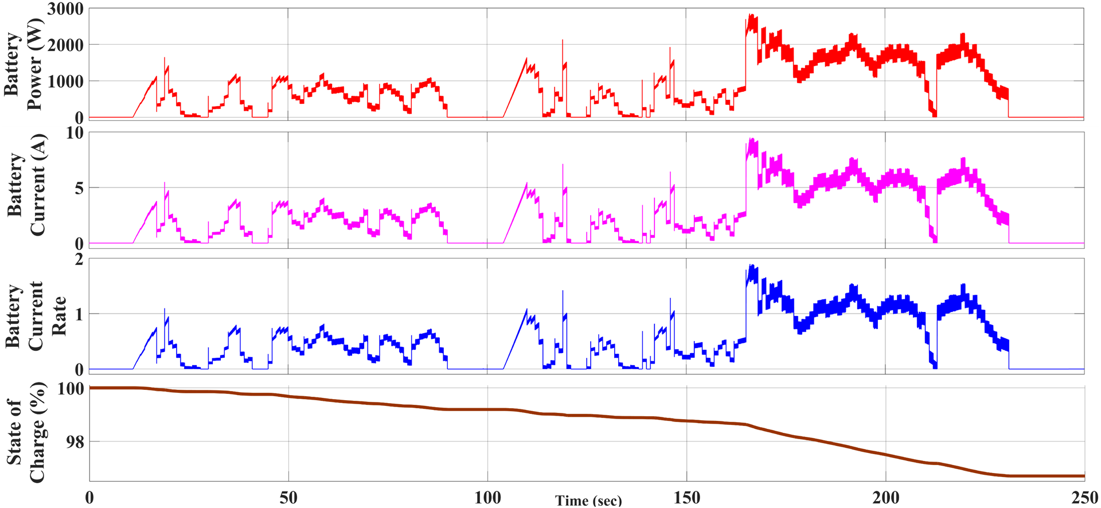

Fig. 9. Battery Characteristics

The slip is approximately zero for perfect rolling movement of the tire. The net forces and torques acting on the vehicle's motion determine the vehicle's motion. Pitch torque and normal acceleration together determine the net normal force applied to the front and rear wheels of the vehicle. These forces ensure the equilibrium of forces on the vehicle system during motion. So, the essential specifications exhibited by the traction motor must meet the demand for acceptable behavior of overall control and operation of the vehicle body.

# CONCLUSION

It is concluded from this work that various dynamics of the vehicle wheel system can be premeditated by developing an EVPT emulator system. This paper successfully encounters the following realizations.

* The analysis's findings demonstrate the traction motor's resilience and brisk dynamic reaction to changes in torque, speed, or power needs.
* The simulation carries out the timely task of accurately controlling the EVPT system in various operational scenarios.

# ACKNOWLEDGEMENT

The Project and Research Laboratory of Delhi Technological University's Electrical Engineering Department in New Delhi, India, provides support for this study.

# REFERENCES

1. Hossein D. (2015). Global role and collaboration of OEM and suppliers in making successful electric vehicles. IEEE Transportation Electrification Conference and Expo.10.1109/ITEC.2015.7165722.
2. Berman B. & Gleb. (1974). Propulsion Systems for electric cars. IEEE Transactions on Vehicular Technology, 23(3), 61-72. 10.1109/T- VT.1974.23575.
3. L. G. O’Connell, “Electric Vehicles: A clean, energy-efficient urban transportation alternative,” EPRI Rep., vol. 30, no. 5, Sept/Oct. 1991
4. Fadul, S.M.E., Aris, I., Misron, N., Halin, I.A., & Iqbal, A.K.M.P. (2017). Modelling and simulation of electric drive vehicle based on Space Vector Modulation technique and Field Oriented Control strategy. Paper presented at 2017 International Conference on Communication, Control,

3Khartoum, Sudan. doi: 10.1109/ICCCCEE.2017.7867667

1. Abhishek Karki, Sudip Phuyal, Daniel Tuladhar, Subarna Basnet, Bin Prasad Shrestha. Status of Pure Electric Vehicle Power Train Technology and Future Prospects <https://doi.org/10.3390/asi3030035>
2. EV Volumes, now part of J.D. Power, Global EV sales for 2023 H1 <https://ev-volumes.com/news/ev/global-ev-sales-for-2023-h1/>
3. Jose Manuel da Fonte Terras, Andre Neves, Duarte M. Sousa, Member, IEEE, and Antonio Roque. Modelling and Simulation of a Commercial Electric Vehicle. 2010 13th International IEEE, Annual Conference on Intelligent Transportation Systems Madeira Island, Portugal, Sep (2010).
4. Philip L. Heirigs and Jay Gordon Preconditioning Effects on I/M Test Results Using IM240 and ASM procedures. Vol. 105, section 4: Journal of Fuels and Lubricants (1996)
5. Claudio R., Davide P., Marco B. & Domenico C. (2017). Management of multi-drive powertrain for fully electric vehicle in degraded operating conditions. IEEE vehicle power and propulsion conference. 10.1109/VPPC.2017.8331019.
6. Sonia Moussa, Manel Jebali Ben Ghorbal. Shephard Battery Model Parametrization for Battery Emulation in EV Charging Application. 2022 IEEE International Conference on Electrical Sciences and Technologies in Maghreb (CISTEM).
7. Emma A. & Torbjorn T. (2016). Performance Analysis of current BEV’S based on a comprehensive review of specifications. IEEE Transactions on Transportation Electrification 2(3), 270-289.10.1109/TTE.2016.2571783.
8. Masood G. & Xingyong S. (2019). Powertrain Energy Management for Autonomous Hybrid Electric Vehicles with flexible driveline power demand. IEEE Transactions on Control Systems Technology, 27(5), 2229-2236.

10.1109/TCST.2018.2838555.

1. K. L. Butler, M. Ehsani, and P. Kamath, “A MATLAB-based modeling and simulation package for electric and hybrid electric vehicle design, “IEEE Trans. Veh. Technol., vol. 48, no. 6, pp. 1770-1778, Nov. 1999.